- Define a synapse
(2 marks)

_______________________________________________________________________________________

_______________________________________________________________________________________

_______________________________________________________________________________________

Outline the structure of the peripheral nervous system
(4 marks)

_______________________________________________________________________________________

_______________________________________________________________________________________

_______________________________________________________________________________________

After a car accident, Amy suffered a severe damage to her brain. She was still able to read and understand people when they speak however she was unable to speak proper language that could be understood.
Identify the area of the brain that was damage and describe its function.
( 2 marks)

_______________________________________________________________________________________

_______________________________________________________________________________________

_______________________________________________________________________________________

Identify the following parts of the brain.
(6 marks)
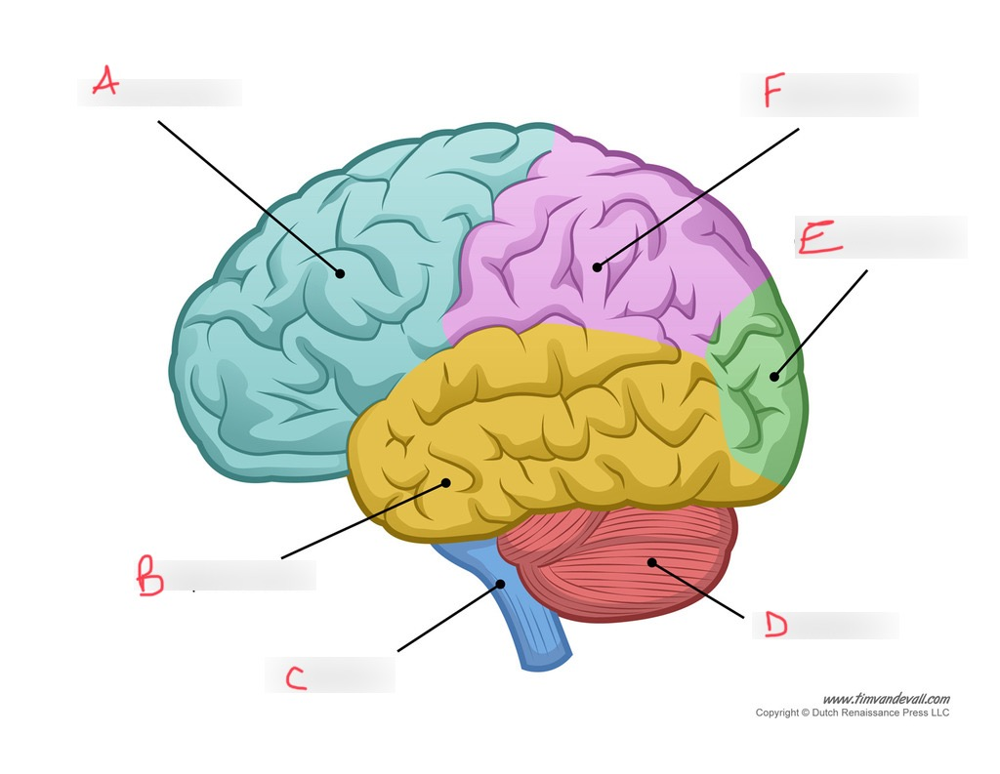

A)___________________

B)___________________

C)___________________

D) ___________________

E)___________________

F)___________________

Describe the transmission of messages across a synapse.
( 7 marks)

_______________________________________________________________________________________

_______________________________________________________________________________________

_______________________________________________________________________________________

_______________________________________________________________________________________

_______________________________________________________________________________________

_______________________________________________________________________________________

_______________________________________________________________________________________

_______________________________________________________________________________________

_______________________________________________________________________________________

_______________________________________________________________________________________

_______________________________________________________________________________________

_______________________________________________________________________________________

Define the term psychoactive drug
(2 marks)

_______________________________________________________________________________________

_______________________________________________________________________________________

_______________________________________________________________________________________

Contrast between excitatory and inhibitory neurotransmitters
(4 marks)

_______________________________________________________________________________________

_______________________________________________________________________________________

_______________________________________________________________________________________

Name the two divisions of the autonomic nervous system and contrast between their main functions.
(4 marks)

_______________________________________________________________________________________

_______________________________________________________________________________________

_______________________________________________________________________________________

